SIMATS ENGINEERING
ASSESSMENT TOOL 1

NAME:DIVYA SHREE.K
REG NO:192521376
COURSE NAME: COMPUTER NETWORKS
COURSE CODE: CSA0703

COURSE OUTCOME COVERED

CO4:
Design network topologies star, mesh, bus, and hybrid using networking devices, transmission media, and cabling standards
(BL2, BL6)

Assessment Tool Weightage: 40%

Annexure A

Coding challenge

- Develop a Python program that generates a Star Topology for a given number of hosts connected to a central switch. The program should accept the number of hosts as input and display the topology either in ASCII format or a graphical representation. For each host, print the host label, the name of the central switch, and the corresponding Cat6 UTP cable length connecting the host to the switch. Verify that all hosts are connected through the central switch and explain how the star topology facilitates reliable communication in a local area network.

- Write a Python function named validate_segment(length_m) to verify whether a given UTP cable segment satisfies the IEEE 802.3 Ethernet standard, which specifies a maximum cable length of 100 meters. The function should return True for valid cable lengths and return False along with an appropriate error message for invalid lengths exceeding the permissible limit. Demonstrate the correctness of the program by executing it with at least three different test cases and interpret the results.
- Develop a Python program to simulate the operation of the Carrier Sense Multiple Access with Collision Detection (CSMA/CD) protocol in a star topology consisting of four hosts connected through a central switch. The program should simulate frame transmission attempts, detect transmission collisions, calculate random back-off intervals, and continue transmission after the waiting period. Record every collision event, transmission attempt, and back-off interval in a log file named csma_log.txt, and analyze how CSMA/CD minimizes data transmission conflicts in Ethernet networks.

- Develop a client-server application using Python's socket library to simulate communication between two hosts connected through a central switch in a star topology. The server should receive frames from the client, forward them appropriately, and maintain a simulated MAC Address Table. After each successful frame transmission, display the updated MAC address table showing the learned MAC addresses and associated ports. Explain how MAC learning and frame forwarding are performed in Ethernet switches.

- Design and implement a Python class named StarSwitch that models the basic functionality of an Ethernet switch. The class should include methods such as add_port(host_id) to connect a host, remove_port(host_id) to disconnect a host, and broadcast(frame) to transmit a frame to all connected ports except the source port. The program should maintain a record of active ports and log every broadcast operation, indicating the source host and the destination hosts that successfully receive the frame. Demonstrate the implementation using multiple hosts and explain the significance of broadcasting in Ethernet communication.

RUBRICS FOR CALCULATION

Criteria | Weightage | Exemplary (4) | Proficient (3) | Developing (2) | Beginning (1)
Problem Understanding | 15% | Fully understands the problem and requirements; no clarification needed | Understands most requirements with minor clarification | Partial understanding; misses some requirements | Poor understanding of the problem
Algorithm Design | 20% | Efficient, optimal, and well-structured algorithm | Correct algorithm with minor inefficiencies | Basic approach but not optimal | Incorrect or no clear algorithm
Code Quality | 15% | Clean, well-organized, readable, and properly formatted code | Mostly clean code with minor issues | Code is somewhat unclear or inconsistent | Poorly written, unreadable code
Functionality | 20% | Code works perfectly for all test cases | Works for most test cases | Works for limited cases | Does not run or fails major cases
Error Handling | 10% | Handles all edge cases and errors effectively | Handles some edge cases | Limited error handling | No error handling
Efficiency | 10% | Highly optimized in time and space complexity | Reasonably efficient | Some inefficiencies | Highly inefficient
Documentation & Comments | 5% | Clear and meaningful comments and documentation | Adequate comments | Few or unclear comments | No comments
Testing & Debugging | 5% | Thoroughly tested with multiple cases; no bugs | Tested with some cases | Minimal testing | No testing done

1.Star Topology Simulation

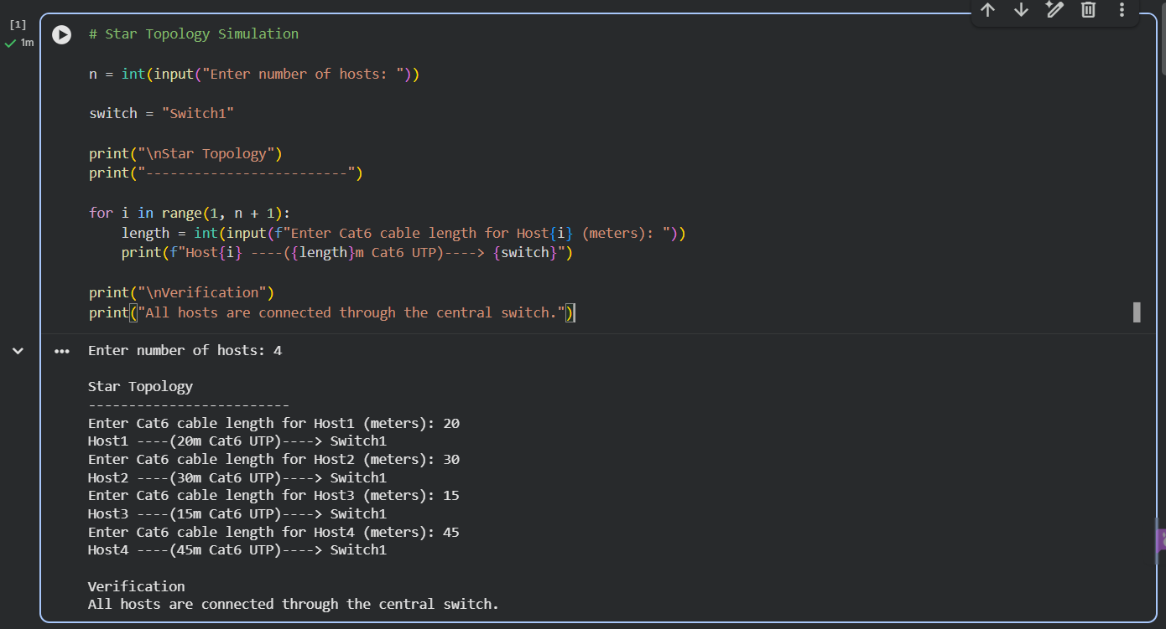

2. IEEE 802.3 Cable Validation

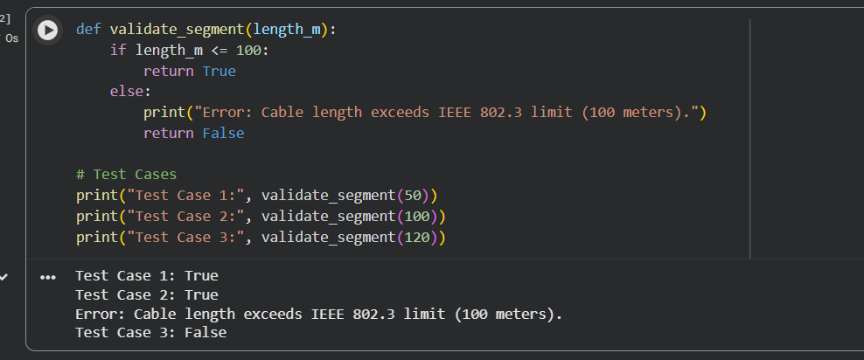

4. Client-Server Socket Program

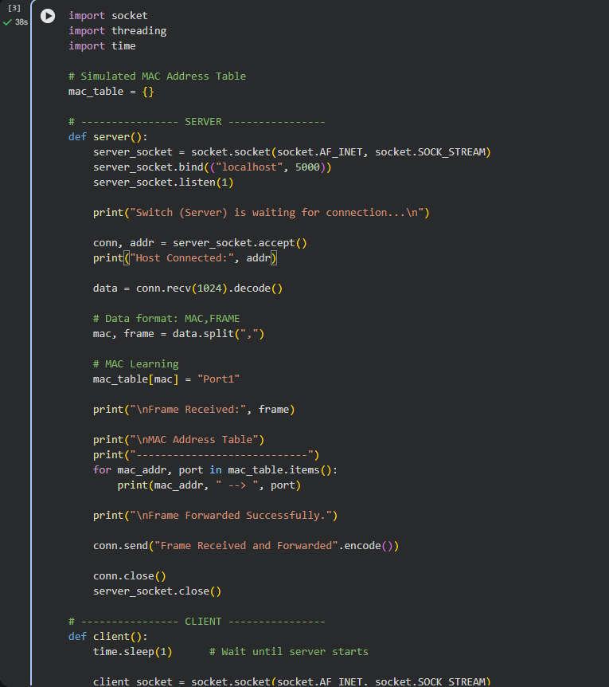

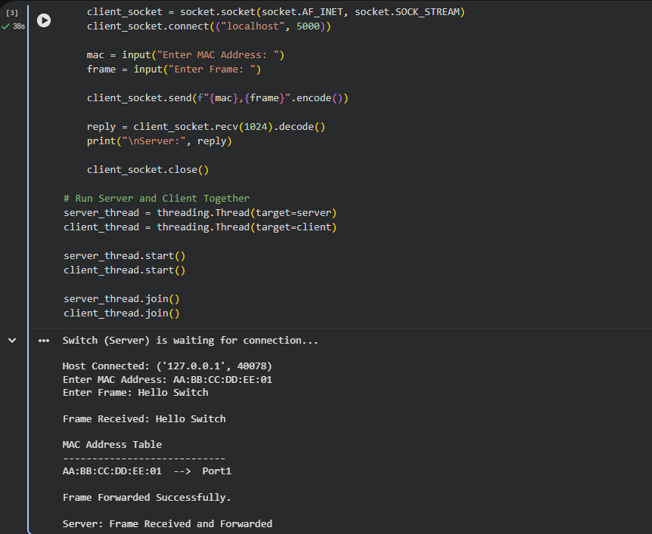
5. Star Switch Class

